1. These files are missing (not linked)

* **eligible-blue-card.css**
* **review-customers.css**
* **policy-cover-tiles.css**
* **additional_coverages.css**
* **red-quote-cta-card.css**
* **related-articles.css**
* **blue-pods.css**
* **style_helper.js**

**Many more files are not linked**

1. **Marked class should be col-lg-4**

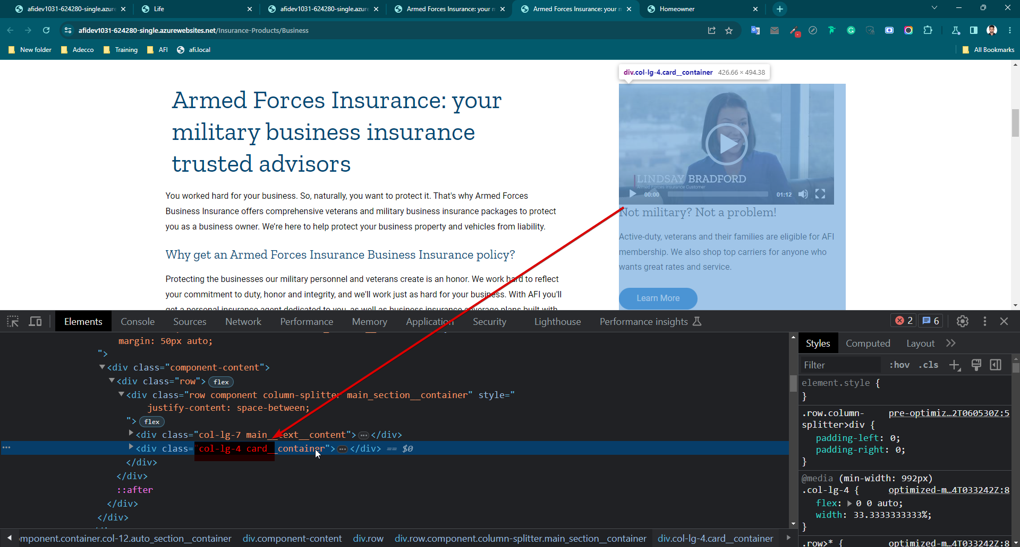

1. Image is missing in “insurance Life” page. Also breakpoint need 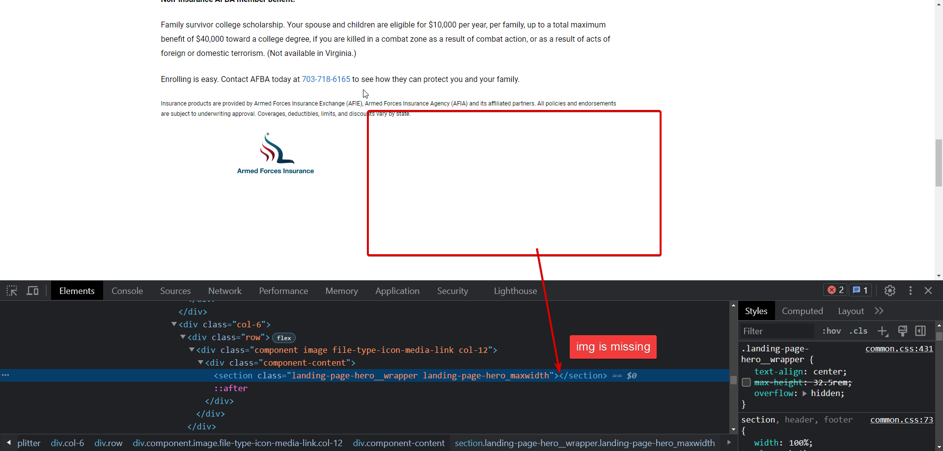

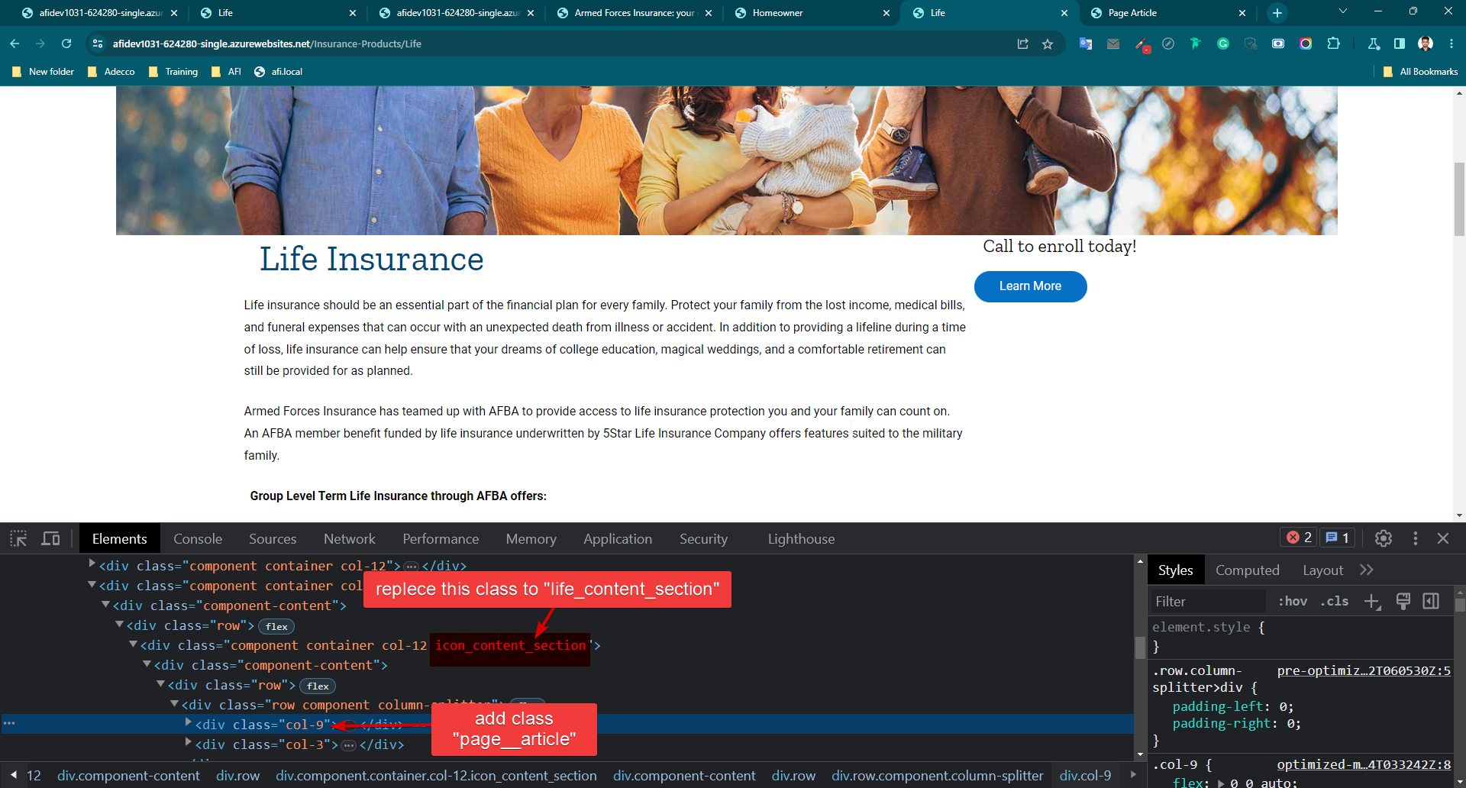

1. Life page (imag’s parent div) A screenshot of a computer

   Description automatically generated
2. Life page Blue Pods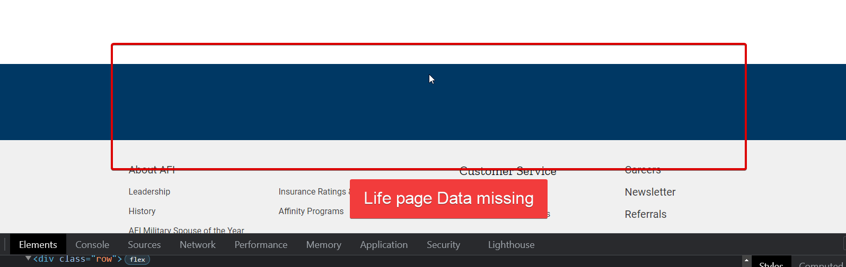
3. **Render Page** A screenshot of a computer

   Description automatically generated with medium confidence

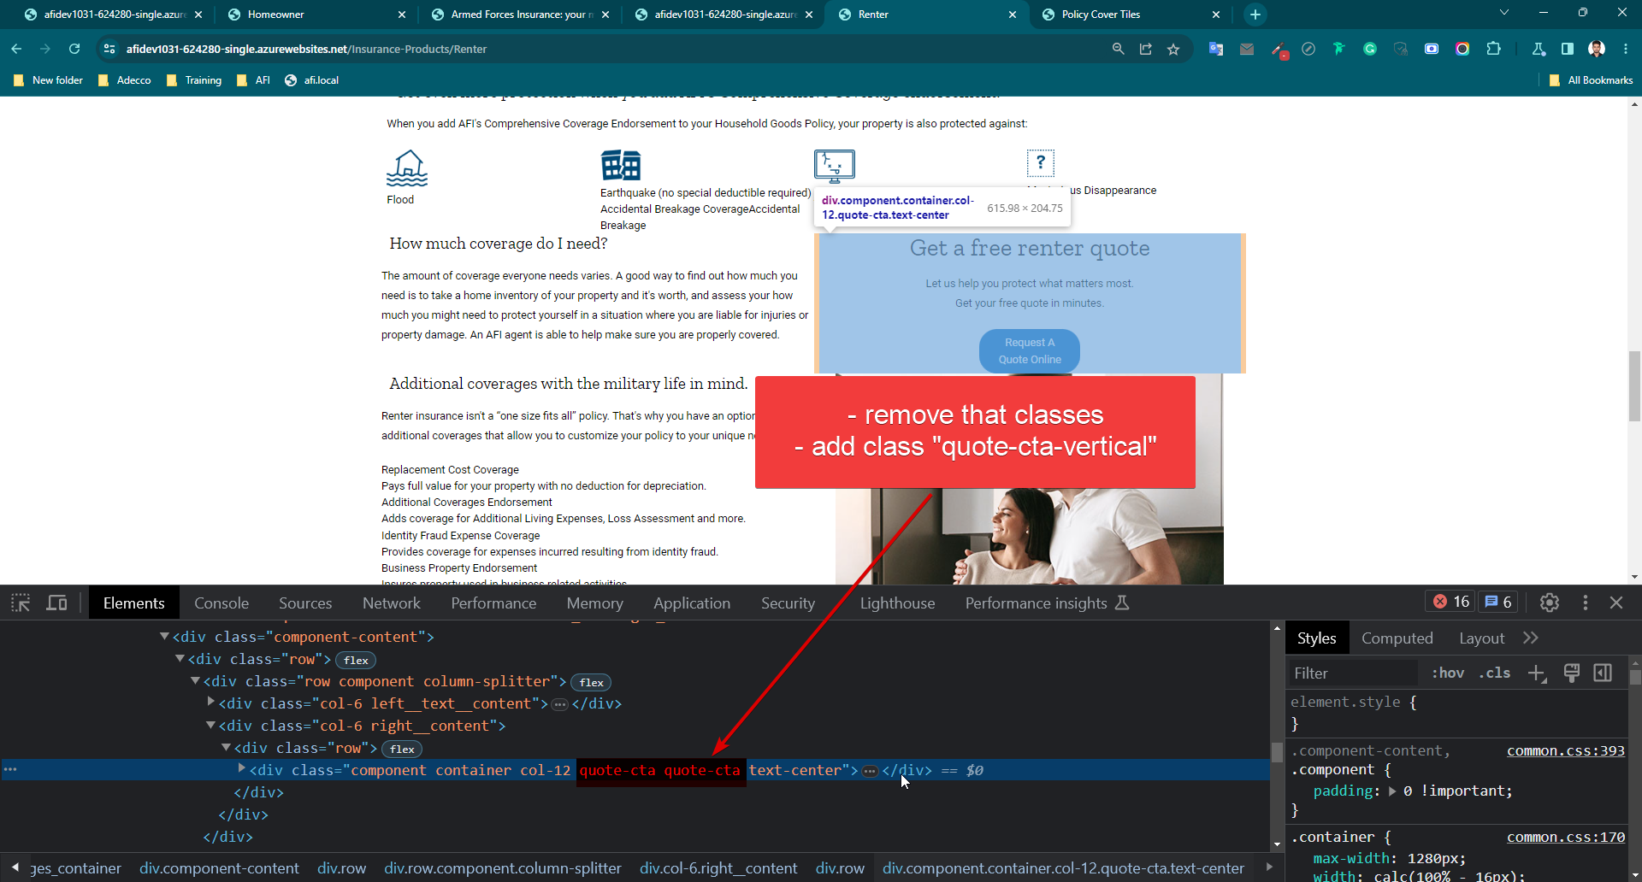

1. **Homeowner page—add class “homeowner”**

